1. List (Vector List)

The list<QString> is a functionality that allows fast index based access and operations to items within said list.

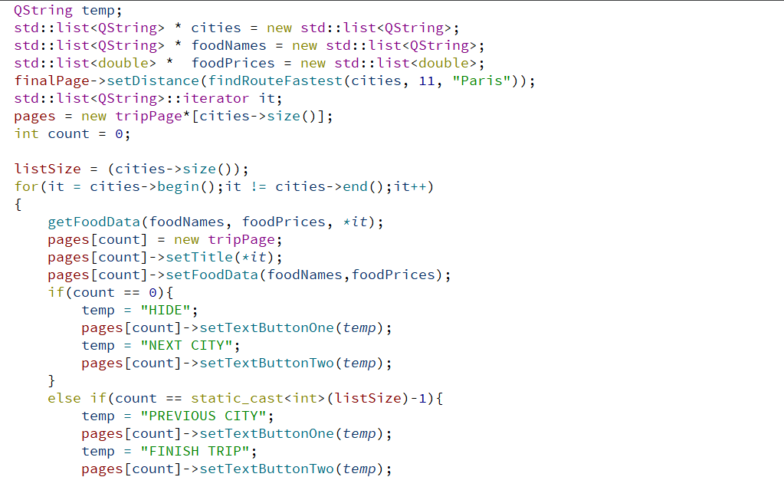

1. Struct

Struct is a part of the city class which includes the string arrays of food items and food descriptions

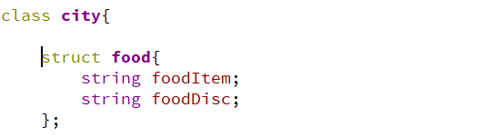

1. Array Food List

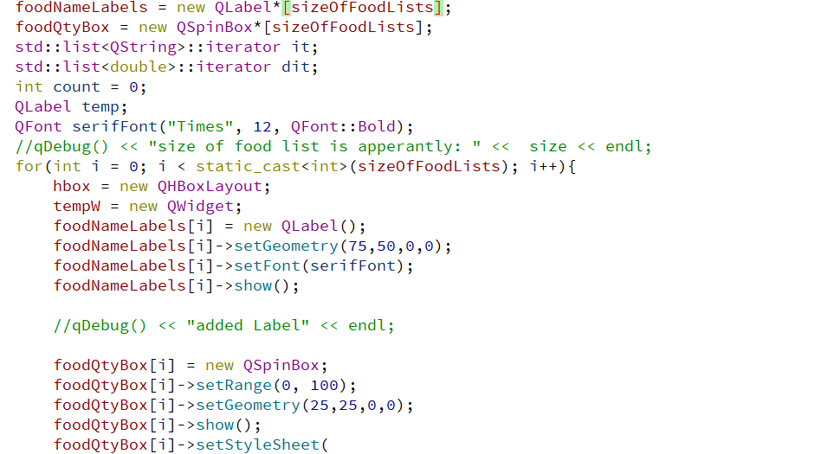foodNameLabels is an array of Qlabel fooditems as well as QSpinBox keeping track of the quantity of foods